Chicago Chinese Community Greeting Beijing 2008 Athletic Meet
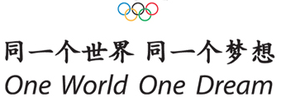

Proposal
February 18, 2008

Introduction: The Olympics Games have been held every 4 years for 112 years since 1896. China has never had the chance to host the Olympics until this year. History is being made and Beijing will be the host city for the XXIX Olympic Games. As the core concepts of the Beijing Olympics “Green Olympics, High-tech Olympics and People's Olympics” are being demonstrated, it is a strong belief that the Beijing Olympics would leave a unique legacy to China and an unforgettable memory to the rest of the world.

The slogan of Beijing Olympics is "One World One Dream". Indeed, this is a dream that not only for China, but also for the whole world to embrace and cherish. It is a dream to organize the Olympic Games and share the essence of the universal values of the Olympic spirit emphasizing “unity, friendship, progress, harmony, participation and the will to dream for the impossible.” These values constitute the beautiful ideal for all mankind. China is fortunately privileged to join the world to demonstrate these universal values of the Olympic spirit that is cherished by the global community and human civilization.

We, the overseas Chinese in Chicago, are very proud and delighted that China has such an opportunity this year in making this dream come true. We are also excited to witness China making this serious and honorable commitment and Beijing flying her colors. In the mean time, we are equally excited to learn that Chicago is a favourite to be chosen as the host city for the 2016 Olympics. Despite the differences in history, language, and customs, we believe that the Olympic spirit will be well manifested in these two cities without any doubts.

Both cities are related so closely to us that we wish we could do something to express our joyous sentiment. To that end, we plan to propose a mini series of Olympic events to be held in Chicago from May to July this year to correspond with the 2008 Olympics in Beijing. However, we understand that it is a great challenge for us due to our limited resources. Yet we believe, as long as we have the encouragements and supports we need, this challenge is surmountable and we can get the missions accomplished.

The Greeting Beijing 2008 Meet are intended for everyone who loves the Olympics. To make use of limited resources and co-ordinate logistics, we will organize our events on a smaller scale as a Mini-Olympic Series and it will be mainly hosted by the Chicago Chinese community. Friends from other cities and ethnic groups are all welcome to join.

It is our hope to use this Meet to usher in our well wishes for the upcoming Chicago Olympics, and to warm up the spirit and atmosphere for Olympic Games in the Chicago Chinese community. Together with all enthusiastic people who love the Olympics and support this Greeting Beijing 2008 Meet, we hereby sincerely wish the Beijing Olympics, and the prospective Chicago Olympics every success from the bottom of our hearts.
Proposal: We are proposing to run a series of Olympic-related sport events which consists of the Opening Ceremony, Athletics (Field and Track), Football (Soccer), Basketball, Sand Volleyball, Badminton, Tennis, Table Tennis, Canoeing, Swimming and the Closing Ceremony. The Opening Ceremony will be held on May 10, and the Closing Ceremony will be held on July 12. During this period, one sport event will be held each weekend. Various athletic clubs and Chinese student associations have been invited to join as our partners to make this Greeting Beijing 2008 Meet possible.
The events will be held within Chicago and its suburbs. In particular, the Opening and Closing Ceremonies, as well as the Athletics events will be held at one of the stadiums near Chinatown and downtown area. As this Greeting Beijing 2008 Meet purports to be of relatively high profile of publicity, with many of its events including competitors from all ages, a total of about 26,000 audiences are expected.
Objectives: To warmly celebrate the Beijing Olympics 2008 by uniting overseas Chinese in Chicago;
To launch the blessing for a successful 2016 Olympics in Chicago, USA;
To enrich the quality of life and co-operative spirit of the Chinese community;
To create valuable opportunities for people including those from other ethnic groups to foster friendship and share common interests.
Organizer: Mid-America Chinese Recreation Org. (MACRO) will take the leading efforts in developing this Meet. MACRO is a non-for-profit organization and has been successfully organizing and actively participating in a variety of sports in this Chicago Chinese community for a decade. More information about MACRO can be reviewed at: http://macrogroup.org/ .
Co-Organizers: Chinese American Association of Greater Chicago, Chicago Fudan Alumni Association (CFAA), Xilin NorthWest Chinese School, NWU Chinese Students and Scholars Association, UIC Chinese Students and Scholars Association, UC Chinese Students and Scholars Association, IIT Chinese Students and Scholars Association, and Chicago 2016 Committee.
Supporters: Illinois Secretary of State, City of Chicago, Chinese Consulate General in Chicago, 21st Dist Police, 24th Ward Alderman, Chicago Chinatown Chamber of Commerce, Chicago Park District, Shanghai Media Group, Sun Cast TV, World Chinese Weekly, Chicago Chinese News, China Journal, Chinese American News, China Star Media, World Journal, Singtao Newspaper, Chicago China News and Digest, Culture and Life Newspaper, Milwaukee Chinese Times, and other major US and Chinese Media.
Schedule: The major tasks of preparing and running this Chicago Chinese Community Greeting Beijing 2008 Meet are shown in the following table:
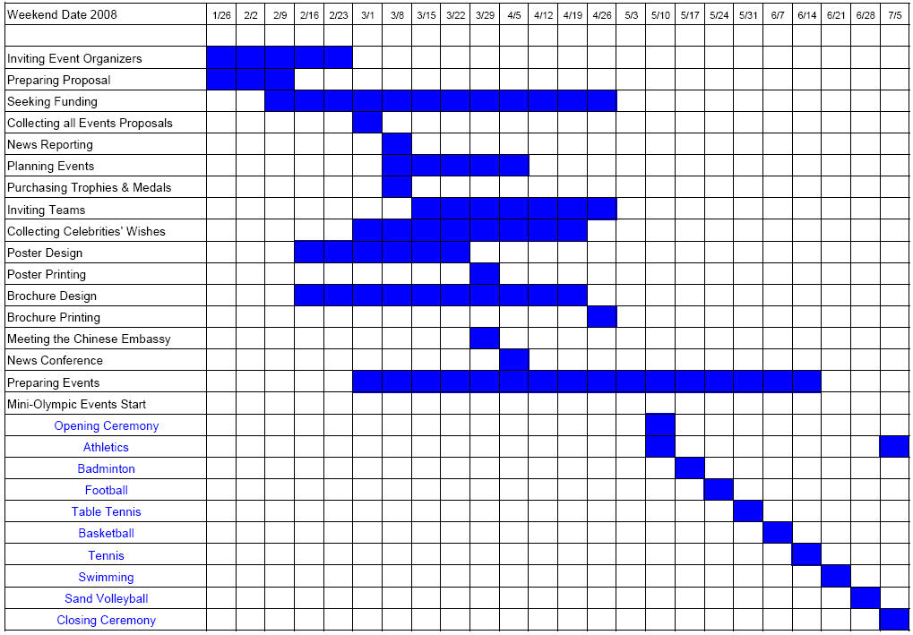
Cost: The overall cost in running this Olympic Series is estimated to be about $155,000 in which the overhead cost is about $105,000.

