Chicago Chinese Community Greeting Beijing 2008 Meet
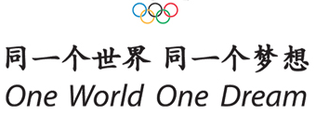

Sponsorship
February 28, 2008

- Special package is shown in the following table:

Package Type | $ Pledged X Quantity | Banner Space at event site | Logo on Numbering Cloth | Free Ad in Brochure | Committee Title
Diamond | $5,000 X 1 | 1/10 | Yes | Cover page inner | Honorary Chairman
Jade | $3,000 X 2 | 1/20 | Yes | Full page inside | Honorary Vice Chairman
Platinum | $1,000 X 3 | 1/40 | Yes | Full page inside | Chairman
Gold | $500 | 1/80 | No | Half page inside | Chairman

- Advertisement on brochure

Full page cover inner (封面內頁及封底) $300
Full page inside (內頁全版) $150
Half page inside (內頁半版) $100
Middle page (分中頁) $400

- Others
Event in particular, sponsor can get 1/5 space for banner:
Opening Ceremony at $3,000
Closing Ceremony at $3,000
Field and Track at $2,000
Badminton at $1,000
Table Tennis at $1,000
Soccer at $2,000
Basketball at $2,000
Swimming at $2,000
Tennis at $1,000
Volleyball at $1,000
Souvenirs
Newspaper advertisement
Individual

